Sending Thank You Emails to Sponsors
You can send a Thank you email to your sponsors right from your walker page! Just follow these steps:
- Make sure that automatic email is enabled on your profile settings. To do that, click the yellow “Edit Profile and Social Sharing” button just under your profile picture. It looks like this:
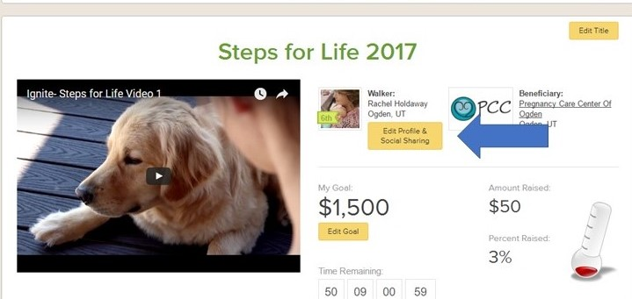

- A window will pop up that allows you to adjust your email and social sharing. Scroll down until you see “Enable Email Sharing”:
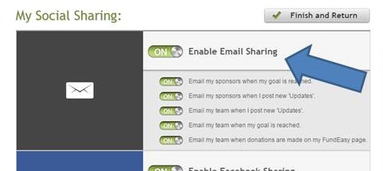

- Make sure that the switch icon is turned to “ON”. (Pictured above) If it’s “OFF”, simply click the word “OFF” to turn it to “ON”.
- After turning the setting to “ON”, make sure that the “Email my sponsors when I post new updates is turned to “ON”. If it’s “OFF”, simply click the word “OFF” to turn it to “ON”.
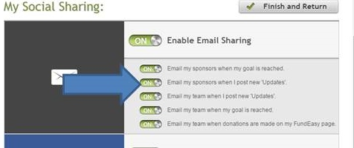

- To save your changes, click “Save and Return”.
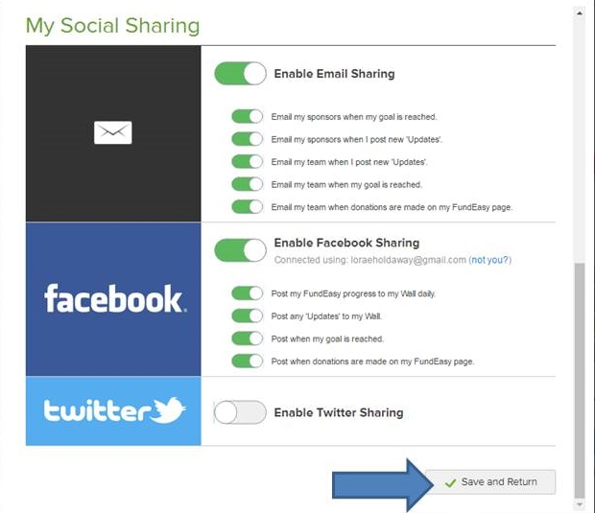

- You will be taken back to your walker page. From there, click the “Updates” tab:
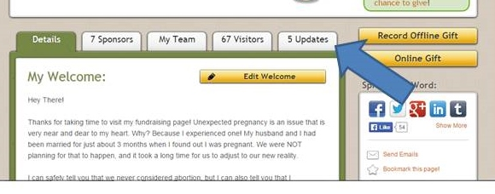

- Then click “Post New Update”:
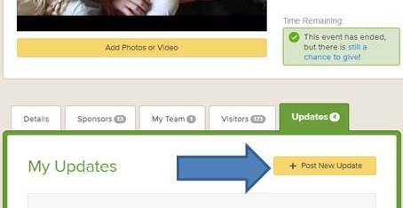

- Fill in a subject line and message.
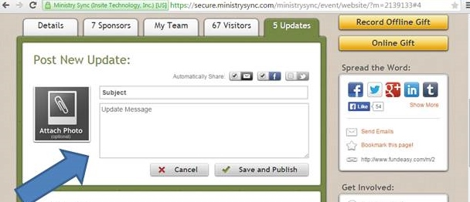
- Click “Save and Publish”.
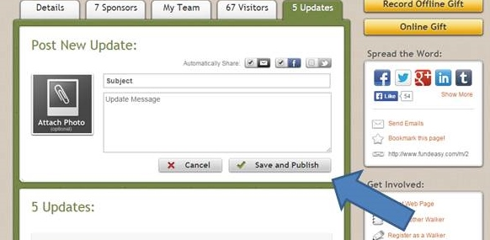
- Your “Thank You” Update will automatically be sent to all your sponsors that provided an email address!
Thank you for your participation in this year’s Steps for Life!

