Logging In To My Walker Page
After registering as a walker, follow these directions to log in to your walker page. If you haven’t registered yet, follow the directions on our “Walker Registration Instructions” link on our “Walker Tools” page.

- Type www.ogdenpcc.org into your search bar. You should be taken to the PCC’s webpage.

- Click on the Steos for Life Banner that looks like this:
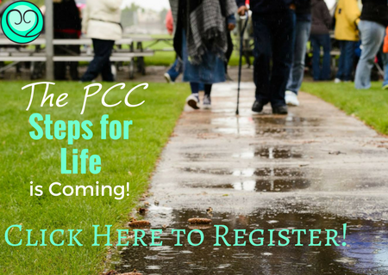

- You’ll be taken to our Steps for Life page that looks like this: 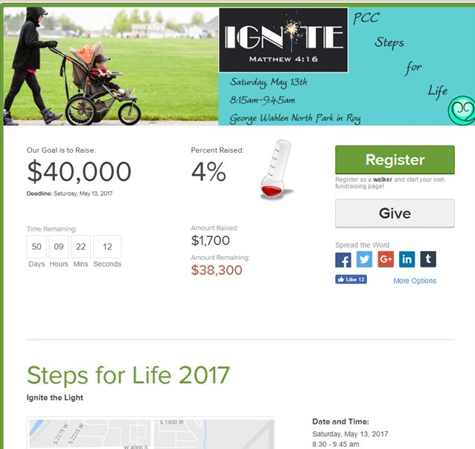

- From there, click the “Sign In” button at the top of the page.
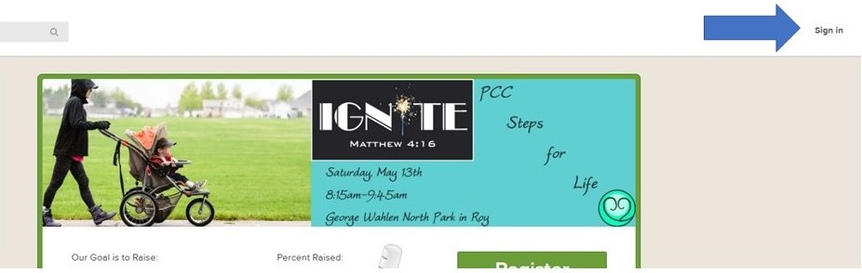

- Enter your username and password, or click “Log in with Facebook” if you registered using your Facebook account. If you encounter problems, see our “Troubleshooting Registration Problems” link, or call Rachel at 801-612-9293.

- After entering your username and password, the page should reload. At the top of the screen, you should now see a “My Page” button.
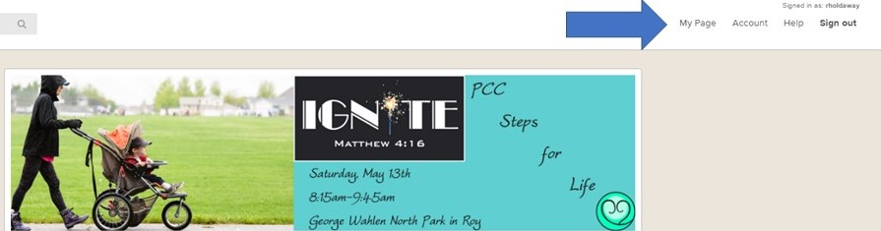
- Click the “My Page” button, and you will be taken to your personal walker web page. You can continue gathering sponsors from there! (If you are given a message that says “You’re already on your page!” scroll to the bottom of the page you’re on and find your walker profile from the list provided. Click on it, and you’ll be taken to your page.)

